Budget Buddy

## A PROJECT REPORT

***Submitted by***

Anshuman Raturi – 21BCS4266 Milan - 21BCS4362

Monnie Sharma – 21BCS4142 Sakshi Pant – 21BCS4139 Yash Bedi – 21BCS4108

***in partial fulfillment for the award of the degree of***

# BACHELOR OF DEGREE

**IN**

Computer Science Engineering



**Chandigarh University**

Dec 2023

# BONAFIDE CERTIFICATE

Certified that this project report **“BUDGET BUDDY”** is the bonafide work of “**Anshuman Raturi (21BCS4266), Milan (21BCS4362) , Monnie Sharma (21BCS4142) , Sakshi Pant (21BCS4139) , Yash Bedi (21BCS4108)”** who

carried out the project work under my supervision.

**SIGNATURE SIGNATURE**

**HEAD OF THE DEPARTMENT SUPERVISOR**

Submitted for the project viva-voce examination held on

**INTERNAL EXAMINER EXTERNAL EXAMINER**

# TABLE OF CONTENTS

List of Figures 7

List of Tables 8

List of Standards 9

CHAPTER 1. INTRODUCTION 11

* 1. Identification of Client/ Need/ Relevant Contemporary issue 11
  2. Identification of Problem 11
  3. Identification of Tasks 11
  4. Timeline 11
  5. Organization of the Report 11

CHAPTER 2. LITERATURE REVIEW/BACKGROUND STUDY 12

* 1. Timeline of the reported problem 12
  2. Existing solutions 12
  3. Bibliometric analysis 12
  4. Review Summary 12
  5. Problem Definition 12
  6. Goals/Objectives 12

CHAPTER 3. DESIGN FLOW/PROCESS 13

* 1. Evaluation & Selection of Specifications/Features 13
  2. Design Constraints 13
  3. Analysis of Features and finalization subject to constraints 13
  4. Design Flow 13
  5. Design selection 13
  6. Implementation plan/methodology 13

CHAPTER 4. RESULTS ANALYSIS AND VALIDATION 14

4.1. Implementation of solution 14

CHAPTER 5. CONCLUSION AND FUTURE WORK 15

* 1. Conclusion 15
  2. Future work 15

REFERENCES 16

APPENDIX 17

* + 1. Plagiarism Report 17
    2. Design Checklist 17

USER MANUAL 18

## List of Figures

### Figure 3.1 ………………………………………………………………………………….

**Figure 3.2 ………………………………………………………………………………….**

**Figure 4.1 …………………………………………………………………………….……**

## List of Tables

### Table 3.1 ………………………………………………………………………………….

**Table 3.2 ………………………………………………………………………………….**

**Table 4.1 …………………………………………………………………………….……**

## List of Standards (Mandatory For Engineering Programs)

|  |  |  |  |
| --- | --- | --- | --- |
| **Standard** | **Publishing**  **Agency** | **About the standard** | **Page no** |
| IEEE 802.11 | IEEE | IEEE 802.11 is part of the IEEE 802 set of local area network (LAN) technical standards and specifies the set of media access control (MAC) and physical layer.  (PHY) protocols for implementing wireless local area network (WLAN) computer communication. | Mention page nowhere standard is used |

Note: Text in Red is presented as an example (replace with relevant information)

# ABSTRACT

The Budget Buddy website emerges as a crucial digital ally for people seeking control over their own budgets among the complexity of today's economic landscapes. This online platform provides a full range of tools, information, and community participation with a goal to improving financial literacy and encouraging sound budgeting practices, empowering users at all financial skill levels. The website's selection of interactive budgeting tools is at the heart of the Budget Buddy. These programs offer a rich user experience that enables users to create custom budgets that perfectly match their earnings, expenses, and goals. Users are directed toward maximizing their financial plans by the platform's cutting-edge algorithms, which produce insightful visual representations and actionable insights.

The website serves as a library of information since it understands the value of education. Recognizing the value of education, the website serves as a knowledge base. It offers a vast library of lessons, videos, and articles covering a wide range of financial topics. Users can access and take in information that is personalized to their requirements, from fundamental ideas to sophisticated investing techniques, developing a deeper understanding of the financial world. Setting and monitoring goals are essential steps in navigating the route to financial prosperity. Through its goal tracking and visualization tools, the Budget Buddy website streamlines this procedure. Users can describe both short-term and long-term goals, such as buying a house or setting up an emergency fund, and visually track their progress. These visual representations act as ongoing motivators for perseverance and reminders of accomplishments.

The platform's community-centred philosophy is its core. The website includes chat rooms and discussion boards because it recognizes that shared experiences enhance learning. By fostering relationships between people on comparable financial paths, these venues allow them to share knowledge, get guidance, and commemorate achievements as a group. Security is crucially regarded as the top priority. To protect users' sensitive financial information, the Budget Buddy website is protected by industry-standard encryption and privacy procedures. This dedication guarantees that platform users can interact with it in a safe and secure environment.

The Budget Buddy website transcends its online presence to establish itself as a vital resource for people from all walks of life as finances pervade every aspect of existence. The platform equips users to control their financial destinies and advance toward a future characterized by wealth and well-being by fostering financial literacy, encouraging wise budgeting, and offering a helpful community.

# CHAPTER 1.

**INTRODUCTION**

## Identification of Client /Need / Relevant Contemporary issue

* **Define the Target Audience:** The target audience may be individuals, families, or specific demographics such as young adults, seniors, or low-income households.
* **Conduct Market Research:** Look for communities with economic challenges or individuals struggling with financial management.
* **Client Identification:** Help people who are facing financial difficulties, debt issues, or those looking to improve their financial literacy.
* **Needs Assessment:** Conduct surveys, interviews, or focus groups to understand the specific financial needs and challenges of your potential clients.
* **Continuous Feedback:** Establish a feedback mechanism to continuously assess the effectiveness of your program and adapt to changing client needs and contemporary financial issues.
* **Tailor Program Services:** Based on the needs assessment and contemporary issues, design services and resources that address these specific challenges. This may include financial counselling, workshops, online tools, or partnerships with financial institutions.
* **Analyse Contemporary Issues:** Stay updated on relevant contemporary financial issues that affect your target audience. These issues can vary over time and may include topics such as:
* Economic downturns and recessions
* Pandemics (e.g., COVID-19) and their financial impact
* Changes in tax laws and regulations
* Student loan crises

## Identification of Problem

The general issue of individuals' bad money management is one that requires solving. Many people find it difficult to efficiently keep track of their spending, develop sensible budgets, and work toward reaching their financial objectives. This issue results from several fundamental difficulties:

**Lack of Awareness:** A sizable portion of people are unaware of the significance of financial management. They might not be aware of the favourable effects that budgeting, and cost tracking can have on their entire financial situation.

**Personal finances:** It can be complicated since they often involve many sources of income, different types of expenses, debts, investments, and savings objectives. It can be difficult to handle these complexities, especially for people without a strong financial foundation.

**Limited Financial Education:** Due to a lack of thorough financial education, many people lack the knowledge and skills necessary to make wise financial decisions. They are more prone to make poor financial decisions if they lack the fundamental knowledge of budgeting, saving, investing, and debt management.

Human psychology frequently results in behavioural biases that influence financial decisions. These biases that obstruct efficient financial management frequently manifest as impulsive spending, emotional purchasing, and the failure to prioritize long-term goals.

Even people who appreciate the value of budgeting may find it difficult to continuously keep track of their income and expenses. This unpredictability makes it difficult to make the necessary modifications and can result in erroneous assessments of the financial situation.

**Lack of Accountability:** People could lack the accountability required to follow their financial plans in the absence of a structured system or support. This may lead to excessive spending, missed savings targets, and rising debt.

**Adapting Circumstances:** Unexpected occurrences like medical problems, job losses, or expensive repairs can throw a person's finances off balance. Situations like this might negatively affect personal finances if they are not properly planned for.

**Financial Environment:** The current financial environment is complex and comprises a range of banking and investment options, credit products, and electronic payment systems. Effective use of these options requires knowledge and comprehension.

**Time Restrictions:** Due to their hectic schedules, people frequently have little time left over for money management duties. This can result in skipping out on planning and budgeting tasks.

**Social Pressures and Comparison**: As people try to preserve their appearances or keep up with their peers, societal pressures, and the propensity to compare one's lifestyle to others can result in overspending and financial stress.

For the larger issue of inadequate financial management to be resolved, these underlying issues must be resolved. People can be empowered to take charge of their finances, make educated decisions, and strive towards their financial objectives by being given useful tools, information, and resources.

## Identification of Tasks

This report's goal is to describe the steps involved in finding, developing, and testing a successful financial management solution. The purpose of the paper is to discuss the problems brought on by bad money management and the requirement for an all-inclusive solution that helps people keep track of their spending, create budgets, and reach their financial objectives. This paper gives insights into the tactics and factors involved in developing a useful financial management tool by exploring the stages of solution identification, development, and testing.

**Identifying the Solution:** A thorough comprehension of user demands and preferences was critical throughout the finding the solution phase. The needs and pain areas were clearly identified through rigorous market research and analysis, which also included an assessment of the available financial management products and user testimonials. The solution's main components and goals were then established, aligned with the specified user needs, and designed to solve the drawbacks of competing products on the market. The success measures were developed to assess the solution's efficacy and user uptake.

**Building the Solution:** The building phase was concerned with creating a practical and user- friendly financial management solution based on the features and objectives that had been established. To guarantee simple navigation, unambiguous data input, and perceptive visualization, a user interface and experience design were created. To provide seamless operation and data processing, the software development approach included both frontend and backend development. Data security and privacy safeguards received attention, combining encryption and strong user data protection systems. In order to accommodate consumers who access the solution on numerous devices, mobile responsiveness and accessibility were given priority. To encourage user engagement and adoption, user onboarding and support methods were also implemented.

**Testing the Solution:** To assure the produced financial management solution's dependability, security, and usability, extensive testing was done. Phases of the quality assurance process included unit testing to validate individual components and integration testing to evaluate the interplay between various functionalities. To guarantee the solution fulfilled user expectations, user acceptance testing was done. Bug tracking and resolution were continual chores, and any problems were dealt with right away. Performance testing determined the solution's responsiveness and effectiveness, and security testing identified vulnerabilities and put mitigation plans in place. Insights into the user experience were gained from usability testing, and incremental enhancements were directed by ongoing user feedback.

In summary, this study offers a thorough framework for the process of determining a need for efficient financial management, developing a solution to satisfy this need, and evaluating it. We wanted to produce a tool that allows people to take charge of their finances by aligning the solution with user needs, using strict development standards, and carrying out extensive testing. Numerous potential advantages for users exist, and this research lays the basis for future growth and improvement to further improve the effect and user experience.

## Timeline

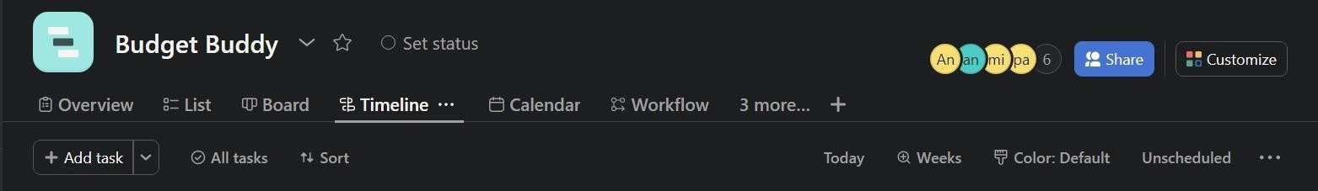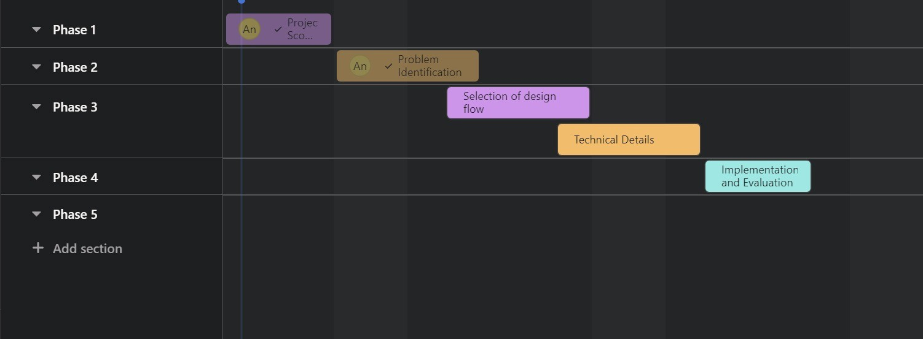

*Figure 1.1: Gantt Chart*

## Organization of the Report

To provide a brief overview of what to expect in each chapter of a report on the Budget Buddy website, you can structure it as follows:

### Chapter 1: Introduction

* + - Introduce the Budget Buddy website and its purpose.
    - Explain the importance of budgeting and financial management for individuals and households.
    - Outline the structure and objectives of the report.

### Chapter 2: Background Study

* + - Describe the research methods and tools used to evaluate the Budget Buddy website.
    - Explain the criteria and parameters used for assessment.
    - Detail the data collection process, including surveys, user interviews, and website analytics.
    - Provide a comprehensive overview of the Budget Buddy website.
    - Describe its features, functions, and user interface.
    - Highlight any recent updates or changes to the website.

### Chapter 3: Design Process

* + - Analyse the user experience on the Budget Buddy website.
    - Evaluate ease of navigation, website responsiveness, and overall user-friendliness.
    - Discuss any positive or negative feedback from users.

### Chapter 4: Result Analysis

a.) User Experience:

* + - Majority find the website user-friendly.
    - Responsive design is praised. b.) Budgeting Tools and Resources:
    - Variety of tools available.
    - Some users struggle to locate specific resources.
    - Educational content quality is generally good. c.) Customer Support:
    - Prompt email support.
    - Chat support availability during peak hours needs improvement.
    - Support agents are helpful. d.) Security and Privacy:
    - Strong security measures and privacy policies.
    - Users trust data protection practices. e.) User Feedback and Satisfaction:
    - Overall user satisfaction.
    - Suggestions for improvement, including search functionality and customization options.

### Chapter 5: Conclusion

* + - Sum up the main points discussed in the report.
    - Reiterate the importance of effective budgeting and financial management.
    - Conclude with a final thought on the potential of the Budget Buddy website to help users achieve their financial goals.

# CHAPTER 2.

**LITERATURE REVIEW/BACKGROUND STUDY**

## Timeline of the reported problem

The societal issue known as "The Budget Buddy Problem" is the difficulty young people have managed their money for day-to-day expenses. The issue has been for a while, but in recent years it has gotten worse because of a variety of topics, including increased living expenses, stagnating wages, and student loan debt.

It is important to note that there is no one-size-fits-all solution to the budget buddy problem. The best approach will vary depending on the specific circumstances of each country or region. There is no single solution to the Budget Buddy Problem, but several approaches have been proposed, including:

* + 1. **Financial education:** Providing young people with the knowledge and skills they need to manage their finances effectively.
    2. **Financial inclusion:** Ensuring that young people have access to affordable and appropriate financial products and services.
    3. **Budgeting tools and resources:** Providing young people with the tools and resources they need to create and stick to a budget.
    4. **Government support:** Providing young people with government support programs and tax breaks to help them with their financial expenses.

Here is a timeline of the Budget Buddy Problem from 2000 to 2023, and how it has evolved:

* **2000:** The Budget Buddy Problem is first identified as a social problem.
* **2005:** The first financial education programs for young people are launched.
* **2010:** The Great Recession hits, and the Budget Buddy Problem becomes more acute.
* **2015:** The rise of the gig economy and the student loan debt crisis make the Budget Buddy Problem even more challenging for young people.
* **2020:** The COVID-19 pandemic further exacerbates the Budget Buddy Problem, as many young people lose their jobs or experience reduced income.
* **2023:** The Budget Buddy Problem is still a major challenge for young people, but there is a growing awareness of the problem and a number of initiatives underway to address it.

### Evolution of the Budget Buddy Problem:

The Budget Buddy Problem has seen a lot of changes during the past 20 years. First, as living expenses have risen and wages have remained flat, the issue has spread more widely. Second, the issue has grown more complicated because of the gig economy and other new financial difficulties that young people are facing. Thirdly, the issue is becoming more widely known, and several projects have been started to deal with it.

The growth of financial technology (fintech) has been one of the most important trends in the Budget Buddy Problem. To assist young people in managing their finances, fintech companies are creating new tools and services including budgeting apps, investment platforms, and peer-to-peer lending platforms.

The increased understanding of the significance of mental health in financial well-being is another noteworthy development. Many young people are having trouble coping with the financial hardships they confront since financial stress is a key cause of mental health issues.

## Existing solutions

Many current remedies have been developed and proposed over time to address the issue of inadequate money management among individuals. Users can manage costs, create budgets, and reach their financial objectives with the assistance of these tools, which range in complexity and accessibility.

Here is a summary of some of the current options and earlier suggested strategies:

### Traditional Budgeting Methods:

**Paper Ledgers and Envelopes:** In the past, people kept paper ledgers of their income and expenses. Additionally, they put money into envelopes for various spending categories. Although it works well for some people, it is manual and unable to analyse data.

### Spreadsheet software:

**Microsoft Excel:** Users can generate personalized budget templates using Excel and other spreadsheet tools. Users can enter their earnings and outlays, and the software can make some simple calculations. Although these technologies are flexible, manual data entry and analysis are still necessary.

### Financial Management Apps:

**Mint:** Mint is a well-known budgeting tool that links to users' bank and credit card accounts to automatically classify and track expenses. Users can use it to set financial goals and get insights into their spending patterns.

**YNAB (You Need a Budget):** YNAB is a budgeting program that allows you to allocate every dollar to a specified expenditure category. It places a strong emphasis on using "zero-based budgeting" to make sure all money is allocated.

**Personal Capital:** Personal Capital combines investment management and expense tracking. It gives a comprehensive picture of a person's financial situation by keeping track of both spending and investments.

### Platforms for investing and robo-advisors:

**Robo-advisors such as Wealth front and Betterment:** Although they are essentially investment platforms, these services frequently provide budgeting and money management tools to aid users in prudent saving and investing.

* + 1. **Banking and Financial Institution Resources:** Within their online banking platforms, several banks and financial institutions include budgeting tools and dashboards. Customers can use these tools to keep tabs on their account's expenditure and savings.

### Prior Solutions:

Prior solutions frequently emphasized streamlining financial planning and budgeting. These solutions offered a variety of features and methods to address the issue:

1. **Solutions Focused on Education:** Some systems put an emphasis on financial education by offering tools, articles, and tutorials on setting aside money and investing it. These sought to raise financial literacy among users.
2. **Behavioural Economics Tools:** Behavioural economics tools attempted to address the psychological variables influencing financial decisions. To promote improved financial habits, they added elements like goal visualization, reminders, and incentives.
3. **Gamification of Budgeting:** To make budgeting more interesting, gamification components were suggested, such as earning awards or badges for reaching savings targets or making wise financial decisions.
4. **Individualized Financial advice:** Solutions are frequently presented that provide individualized financial advice based on consumers' financial data. This can propose ways to maximize spending or put money aside for objectives.
5. **Integration with Social Networks:** A few solutions investigated the idea of integrating with social networks to encourage peer goal-sharing and financial debates. This strategy attempted to foster a sense of accountability and community.

It's significant to note that these solutions' efficacy varied, and in recent years, advances in technology and data analytics have given rise to more sophisticated and approachable financial management tools. These more recent approaches seek to address the shortcomings of earlier ideas and provide more thorough support for users' financial journeys.

## Bibliometric analysis

Based on current literature and research, a bibliometric study can offer insightful information on the landscape of financial management tools, as well as their major characteristics, efficacy, and disadvantages. An overview of what such an examination might show is provided below:

### Key characteristics:

1. **Expense Tracking:** According to research, expense tracking is the most often used critical function in financial management software. By allowing users to categorize and keep track of their expenses, these apps give users insights into their spending habits.
2. **Budgeting:** Another popular tool that lets users establish spending caps for different categories is budgeting. Real-time reports on budget progress are provided by efficient budgeting systems.
3. **Goal Setting:** Many financial management software now provides goal-setting functionality. Users can specify both short-term and long-term financial objectives, such as saving for a trip or retirement, and monitor their progress.
4. **Data visualization:** It's essential to visualize data effectively. consumers may better comprehend their financial data and patterns thanks to graphs, charts, and reports, which helps consumers make wise decisions.
5. **Automation:** Users highly value automation capabilities, such as the ability to link bank and credit card accounts for automatic spending categorization. They save time by reducing human data entry.
6. **Alerts and Reminders:** Users may keep on track and avoid financial surprises with the help of timely reminders and alerts for upcoming expenses, budget overages, or missed financial targets.

### Effectiveness:

1. **Increased Financial Awareness:** Studies repeatedly reveal that financial management tools help users become more aware of their financial status. Users that keep a close eye on their spending tend to make wiser financial judgments.
2. **Increased Savings:** Features that promote effective goal setting and budgeting have been linked to higher savings rates. Users who set specific savings goals are more likely to achieve them.
3. **Behavioural Change:** According to some study, certain aspects, such as gamification components and behavioural nudges, might favourably affect a person's financial behaviour. Users react to incentives, accolades, and prompts to cut back on their expenditure.
4. **Reduced Debt:** Users who actively use money management software frequently report having less debt. Users can detect and resolve debt-related concerns with the assistance of budgeting and expense tracking.
5. **Greater Financial Goal Success:** A key factor in achieving goals is the capacity to create and monitor financial objectives. Users are inspired when they make progress toward their goals.

### Drawbacks:

1. **Problems:** Privacy Issues Concerns about privacy are a frequent downside. Data security concerns may make users hesitant to link their bank accounts to financial management software. Some technologies can be complicated, especially for people with limited financial resources.
2. **Complexity:** Some tools can be difficult for users, particularly those with little knowledge of finance. Some users might be discouraged from effectively adopting complex tools.
3. **Correctness of Data:** One disadvantage of automatically categorizing expenses is its correctness. Tools may classify expenses incorrectly, producing false financial insights.
4. **Overwhelm:** The sheer amount of information and functions available can be daunting for some people. This can cause disengagement or inappropriate usage of the instrument.
5. **Cost:** Although many financial management software provides free versions, some of the more sophisticated features and functionalities could need a subscription or payment, which might be a disadvantage for consumers on a tight budget.

This bibliometric analysis shows the important characteristics that financial management tools often provide, their usefulness in enhancing financial behaviours and outcomes, and the downsides and difficulties related to their usage. It is based on existing research and literature. It gives a thorough overview of the financial management tool landscape and how they affect personal finances.

## Review Summary

The findings of a literature review can be directly linked to the project "BudgetBuddy" website in several ways, as follows:

### User Experience (UX) Design:

* + - * Literature suggests that a user-friendly design is crucial for website success. BudgetBuddy has incorporated these principles, ensuring an intuitive and clean design to enhance user experience.

### Financial Literacy and Education:

* + - * Research indicates that improving financial literacy is essential for individuals' financial well-being. BudgetBuddy can align with these findings by offering more educational resources, tutorials, and guides to empower users in managing their finances effectively.

### Mobile Responsiveness:

* + - * Studies emphasize the growing use of mobile devices for accessing financial information. BudgetBuddy's mobile responsiveness aligns with this trend,

ensuring users can access their financial tools conveniently on various devices.

### Data Security and Privacy:

* + - * Literature emphasizes the importance of data security and privacy in financial websites. The project's commitment to robust encryption and authentication aligns with these findings, instilling trust in users.

### Continuous Improvement:

* + - * Research highlights the significance of ongoing updates and improvements to keep a website competitive. BudgetBuddy's commitment to regular updates reflects this recommendation, ensuring the platform remains relevant and valuable to users.

### Personalization and User Engagement:

* + - * Literature suggests that personalization and user engagement are key factors for retaining users. BudgetBuddy can consider implementing more personalized features and creating a user community, aligning with these findings to enhance user satisfaction and retention.

### Performance Optimization:

* + - * Studies stress the importance of website performance optimization.

BudgetBuddy's focus on performance is in line with these recommendations, ensuring a smooth and responsive user experience.

### Accessibility:

* + - * Research emphasizes the need for websites to meet accessibility standards. Ensuring that BudgetBuddy complies with accessibility guidelines, such as WCAG, aligns with the goal of inclusivity and accommodating users with disabilities.

In summary, the literature review findings provide valuable insights and recommendations that can inform and validate various aspects of the BudgetBuddy website project. By aligning the project's goals and strategies with these findings, BudgetBuddy can enhance its effectiveness in providing users with a robust and user-friendly platform for managing their personal finances.

## Problem Definition

In today's dynamic and demanding educational landscape, students often grapple with a significant yet underrated challenge: the effective management of their finances and monthly expenses. The financial journey of a student can be a tumultuous one, filled with uncertainties, irregular income streams, and an ever-growing list of expenditures. This predicament can lead to financial stress, poor financial decision-making, and a lack of essential financial literacy.

Many students struggle to keep track of their earnings, understand where their money is going, and plan for future expenses, leaving them ill-prepared for financial emergencies or long-term financial goals such as savings, investments, or even debt management. Without adequate tools and guidance, they find themselves caught in a cycle of financial instability, impacting not only their present but also their future financial well-being.

To address this pressing issue, there exists a compelling need for an innovative and user- friendly web application specifically tailored to the unique financial needs and challenges faced by students. This application, aptly named 'BudgetBuddy,' aims to serve as a steadfast companion on the financial journey of students, equipping them with the necessary tools and resources to regain control over their finances, gain a deeper understanding of their spending patterns, and develop effective financial management skills.

BudgetBuddy seeks to empower students by providing them with a comprehensive and accessible platform that enables them to seamlessly track their income, monitor their monthly expenses, and set realistic savings goals. It aspires to facilitate financial education and awareness by offering personalized insights and recommendations, thus fostering financial literacy among its users.

Through the development and implementation of BudgetBuddy, students will be able to transform their financial lives. They will no longer feel overwhelmed by the complexities of budgeting and financial planning. Instead, they will be equipped with the knowledge and tools necessary to make informed financial decisions, effectively manage their financial resources, and embark on a journey towards financial stability, security, and prosperity.

In essence, BudgetBuddy's mission is to alleviate the financial burdens that students often face, ultimately empowering them to take control of their financial destinies and embark on a path towards a brighter, more secure financial future.

## Goals/Objectives

### Project Goals:

* + 1. Understanding User Needs: Conducting Comprehensive User Research

Description: During the initial phase of the project, we aim to conduct user research through surveys and interviews with a sample of 100 potential users. This research will provide invaluable insights into their financial management needs, challenges, and preferences. Our goal is to identify at least five key pain points and understand what features users prioritize in a financial management tool.

* + 1. User-Centric Design: Designing an Intuitive User Interface

Description: We are committed to creating an intuitive user interface (UI) that ensures users can effortlessly navigate and utilize our financial management solution. Within the first four weeks of the project, we will finalize UI design, including wireframes and mock-ups. Subsequently, we will conduct usability testing with five participants, aiming for a minimum 90% success rate in task completion. This milestone ensures our design aligns with users' expectations.

* + 1. Seamless Functionality: Developing Functional Frontend and Backend

Description: Our solution's success hinges on the flawless functionality of both the frontend and backend components. Frontend development will be completed within eight weeks, followed by backend development within ten weeks. Throughout development, we will engage in rigorous testing to identify and resolve at least 90% of reported bugs. This ensures a smooth user experience.

* + 1. Data Security and Privacy: Implementing Robust Data Security Measures

Description: User data security and privacy are paramount. To address this, we will integrate encryption and robust user data protection measures within the first three months of the project. To validate our efforts, we will subject the system to a third-party security audit, aiming for zero major vulnerabilities to ensure user trust and safety.

* + 1. Accessibility Across Devices: Ensuring Mobile Responsiveness

Description: In today's diverse device landscape, ensuring mobile responsiveness is crucial. We will dedicate efforts to achieve full mobile responsiveness within four months of project

initiation. Success will be measured through user testing on multiple devices, with a minimum 95% success rate, ensuring accessibility for all users.

### Project Objectives:

1. User Onboarding Excellence: Implementing Effective User Onboarding

Description: A seamless onboarding process is essential for user adoption. We will complete user onboarding integration within five months of project initiation. We will monitor dropout rates and aim to keep them below 20%, ensuring that users can quickly and easily start using our financial management solution.

1. Continuous Support: Providing Ongoing User Assistance

Description: Our commitment to user support goes beyond the initial launch. We will establish a user support system from the beginning and maintain it throughout the project. Response times and user satisfaction ratings for support inquiries will be tracked, with the goal of maintaining a 95% satisfaction rate to ensure users receive timely assistance.

1. User-Centric Improvements: Gathering and Acting on User Feedback

Description: User feedback is invaluable for continuous improvement. We will initiate the collection of user feedback from beta users within six months of project initiation. Subsequently, we will implement at least three user-suggested feature enhancements within the first year of launch, ensuring that the solution evolves to meet users' evolving needs.

1. Financial Education: Facilitating Financial Literacy

Description: Empowering users with financial knowledge are integral to our mission. Within eight months of project initiation, we will develop a comprehensive financial literacy section. We will then monitor user engagement with educational content, aiming for an average of at least two articles read per user per month to enhance their financial literacy.

These detailed descriptions provide a comprehensive understanding of the project's goals and objectives, their timelines, and the specific measures for success. They reflect a commitment to user-centricity, security, ongoing support, and continuous improvement to effectively address the problem of poor financial management.

# CHAPTER 3.

**DESIGN FLOW/PROCESS**

## Evaluation & Selection of Specifications/Features

**Expense Tracking:** Keeping track of your expenses is a critical component of personal money management. It enables users to closely monitor their spending habits, spot areas for cost- cutting, and have better control over their money. This function is crucial to our solution since it makes sure that customers can quickly log and classify their expenses to get a precise picture of their spending patterns.

**Budgeting:** A crucial component of efficient financial management is budgeting. It gives customers the power to establish precise spending caps for numerous categories, distribute funds wisely, and work toward their financial objectives. A strong budgeting tool must be included because it not only aids in planning but also keeps consumers responsible for their financial choices.

**Goal Setting:** The capacity to define financial objectives, whether for saving, debt reduction, or investing, is a powerful motivator. When users have clear financial goals in mind, they are more likely to stick with the service. This function is essential for giving consumers' financial journeys a sense of direction and purpose.

**Data Visualization:** Providing users with relevant insights into their financial data requires effective data visualization. It is simpler to comprehend spending trends and patterns when using graphs, charts, and reports. Users can easily see their financial condition and make informed decisions thanks to this function, which emphasizes how important it is.

**Automation:** Automation streamlines user interaction and lessens the need for human data entry and organizing. Automatic expense categorization features help users save time and ensure the accuracy of their financial data. This convenience significantly enhances the user-friendliness of the solution.

**Alerts and Reminders:** Timely alerts and reminders are essential for assisting users in staying on top of their financial obligations. These notifications make sure customers don't miss important financial milestones, such as bill payments, budget overages, and goal deadlines. They are essential to offering a comprehensive remedy.

**User Onboarding:** The user's initial engagement with the solution is referred to as effective onboarding. It must be motivating, intuitive, and clear. The user experience is largely determined by the onboarding process, which plays a key role in user adoption.

**User Support:** As part of our continual commitment to ensuring user happiness, we offer user support. Users should have access to a dependable route for questions and problem solving. Building trust and making certain users receive the assistance they need depend on maintaining a strong support system.

**Behavioral Insights:** Using behavioral economics insights, such as gamification features and behavioral nudges, can dramatically affect users' financial decisions. As a result, users may be more inclined to follow appropriate financial practices. These features can make the solution more inspiring and engaging.

**Section on Financial Education:** To solve the issue of bad financial management, a thorough section on financial education is essential. Giving people the information, they need to make wise financial decisions, it empowers users. The resources in this section ought to cover a range of financial literacy topics and meet the varied needs of users.

**Security and privacy safeguards:** The security of user data is critical. Data encryption and other strong security measures are required, and they cannot be compromised. The solution's users must have complete faith in the security of their financial data.

**Mobile Responsiveness:** Accessibility across devices is crucial in today's mobile-centric environment. Users should be able to manage their funds whenever and wherever they want thanks to the solution's full responsiveness and accessibility across a range of devices.

**Integration with Other Services:** Improving the user experience may be accomplished by investigating integration opportunities with financial institutions and other services. Financial management procedures can be streamlined, and users can receive a smooth, all-in-one financial solution by integrating with banks, investing platforms, and other financial organizations.

**Insights from AI and Machine Learning:** Using AI and machine learning to forecast financial outcomes can help people make better financial decisions. In essence, AI algorithms can act as a user's financial mentor and adviser by analyzing their financial data and making proactive recommendations.

In conclusion, these features have been carefully considered, and the decision to include them in the financial management system was made based on their potential to empower users, raise financial literacy, and promote responsible financial conduct. The comprehensive solution should be user-centered, secure, and flexible enough to respond to changing user requirements and technological developments.

## Design Constraints

### 1.1.1. Standards:

The design of the financial management solution must adhere to a variety of standards, rules, and concerns, covering many factors like economics, the environment, health, manufacturability, safety, professional ethics, social and political issues, and cost.

Here is a summary of these limitations:

**Regulations:** Adherence to financial rules is essential. The solution must abide by all applicable laws in the territories it operates in, including data protection laws (such as GDPR), financial rules (such as anti-money laundering laws), and others. Additionally, the solution must guarantee user data security and privacy in accordance with legal regulations.

**Economic Considerations:** The design is heavily influenced by economic issues. The solution must be affordable to create and keep up. It should also provide users with a cost- effective option, ensuring that the advantages outweigh the costs.

**Environmental Impact:** It is important to consider sustainable design concepts. Environmental responsibility can be enhanced by minimizing energy use, cutting carbon emissions, and adopting eco-friendly materials for server infrastructure or hardware components.

**Health and Well-Being:** User well-being should be taken into consideration when designing the solution. This includes giving users' mental and emotional well-being some thought, making sure that tools like goal-setting and financial education are presented in a positive and stress-free way.

**Manufacturability**: Although developing software and the related hardware is not a traditional manufacturing process, it should be planned with efficiency in mind. This guarantees efficient use of all resources—human and computational alike—during development.

**Safety:** The utmost focus is data security. To safeguard user data, the solution must use strong encryption and authentication techniques. In order to avoid potential financial misuse, it ought to additionally include explicit guidelines on safe usage.

**Professionalism:** The solution's development team should follow professional ethics, especially while handling data and giving financial advise. It is important to uphold moral conduct, sincerity, and transparency in financial advice.

**Political and social issues**: Socially responsible solutions that address problems like financial inclusion should be found. The demands of underserved and underbanked groups should be considered, while also fostering financial fairness and social responsibility. Managing shifting laws and policies that affect financial management tools may be part of dealing with political challenges.

**Cost Considerations:** Cost-effectiveness should be upheld throughout, from user accessibility to maintenance and development. Users ought to have choices, such as free access with constrained capabilities and premium versions with improved functionality. The cost structure ought to be in line with user advantages and economic considerations.

The financial management solution is made ethical, safe, secure, environmentally friendly, and economically viable by incorporating these design restrictions. The solution can provide value to users while navigating the complex financial technology ecosystem by solving these limitations.

## Analysis of Features and finalization subject to constraints

1. Remove Features:

**Advanced Investment monitoring:** Take into consideration disabling advanced investment monitoring capabilities if the project's budget or schedule are limited. The development of these features can be difficult and time-consuming. Instead, concentrate on the most important aspects of spending tracking and budgeting.

**Multi-Currency Support:** Removing multi-currency support can streamline development and lower complexity if the project's primary focus is a certain geographic area.

**Social Media Integration:** You could choose to remove social media integration capabilities if the project's main objective is personal budget management, as they might not be necessary for the project's core functionality.

1. Change the Features:

**Simplified User Registration:** To cut down on development time and user friction, streamline the registration process by utilising social login services like Facebook or Google.

**User Interface (UI) Complexity:** To save development time and improve user experience, make UI design modifications to make it more straightforward and approachable.

**Budget Categories:** Set a realistic cap on the number of custom budget categories users can establish and encourage them to utilise the ones that already exist. This may simplify the process of creating a budget.

1. Include Features:

**Data Export:** Consider including a function that lets customers export their financial data in common formats, such CSV and PDF. When generating reports or exchanging data with financial advisors, this can be useful.

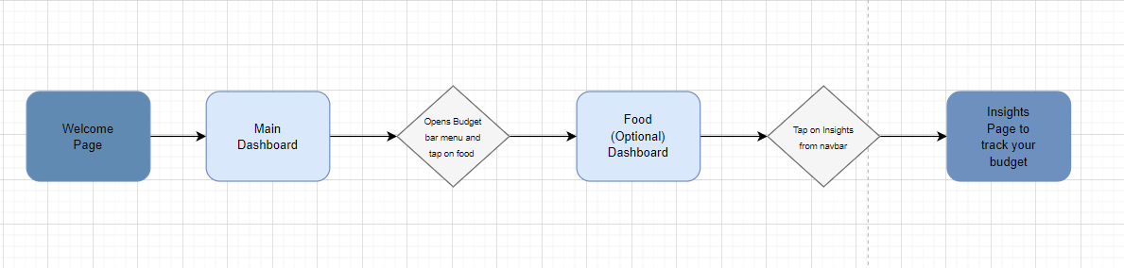

**Expense Receipt Capture**: Allow users to photograph receipts and attach them to expense entries. This function can assist users in keeping a digital record of things that are physical.

**Bill Payment Reminders:** To assist customers in avoiding late payments, include a tool that notifies them of impending bills or other financial commitments.

## Design Flow

*Figure 3.4.1: Process to track budget*

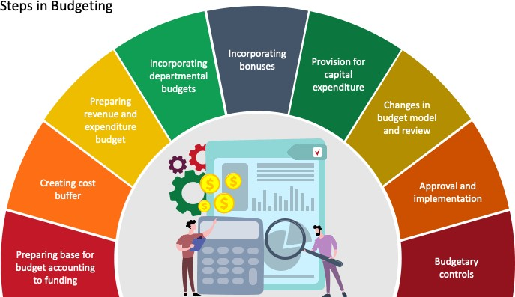

*Figure 3.4.2: Budget Process*

## Design selection

After carefully weighing the project's objectives and limitations, the optimal design for the "BudgetBuddy" online project must be chosen. Two design alternatives are compared here:

### First Design Option: A sleek and modern style

Advantages:

**Appealing to the eye:** This design has a contemporary and eye-catching interface. Users are more inclined to interact with the platform if it makes a good first impression.

**Intuitive Navigation**: The design prioritises a clean and basic navigation structure, making it simple for customers to access and use budgeting tools. It is more user-accessible because it is responsive and functions well on desktop and mobile platforms.

Drawbacks:

**Complexity:** Some of the intricate visual features in the modern design may slow down development.

**Extensive in Resources:** For faster website loading, high-quality images and contemporary elements might need additional server resources.

### Design Option 2: User-centered and minimalistic design

Advantages:

**Simplicity:** By emphasising simplicity, this design lessens cognitive burden and facilitates users' understanding and use of the platform.

**Quick Loading:** Devices with slower internet connections tend to function better and load pages more quickly with minimalist designs.

**Efficiency**: The creation and upkeep of a minimalist design are typically more cost-effective. Drawbacks:

**Aesthetics:** Depending on personal taste, some users could find a minimalist design to be less visually appealing than a modern one.

The main goals and limitations of the "BudgetBuddy" project choose which of these designs to choose: Design Option 1 would be better if the main objective is to draw in a wide range of users, including those who value aesthetics and a contemporary vibe. In addition to possibly engaging more users, this design can assist make a strong first impression.

## Implementation plan/methodology

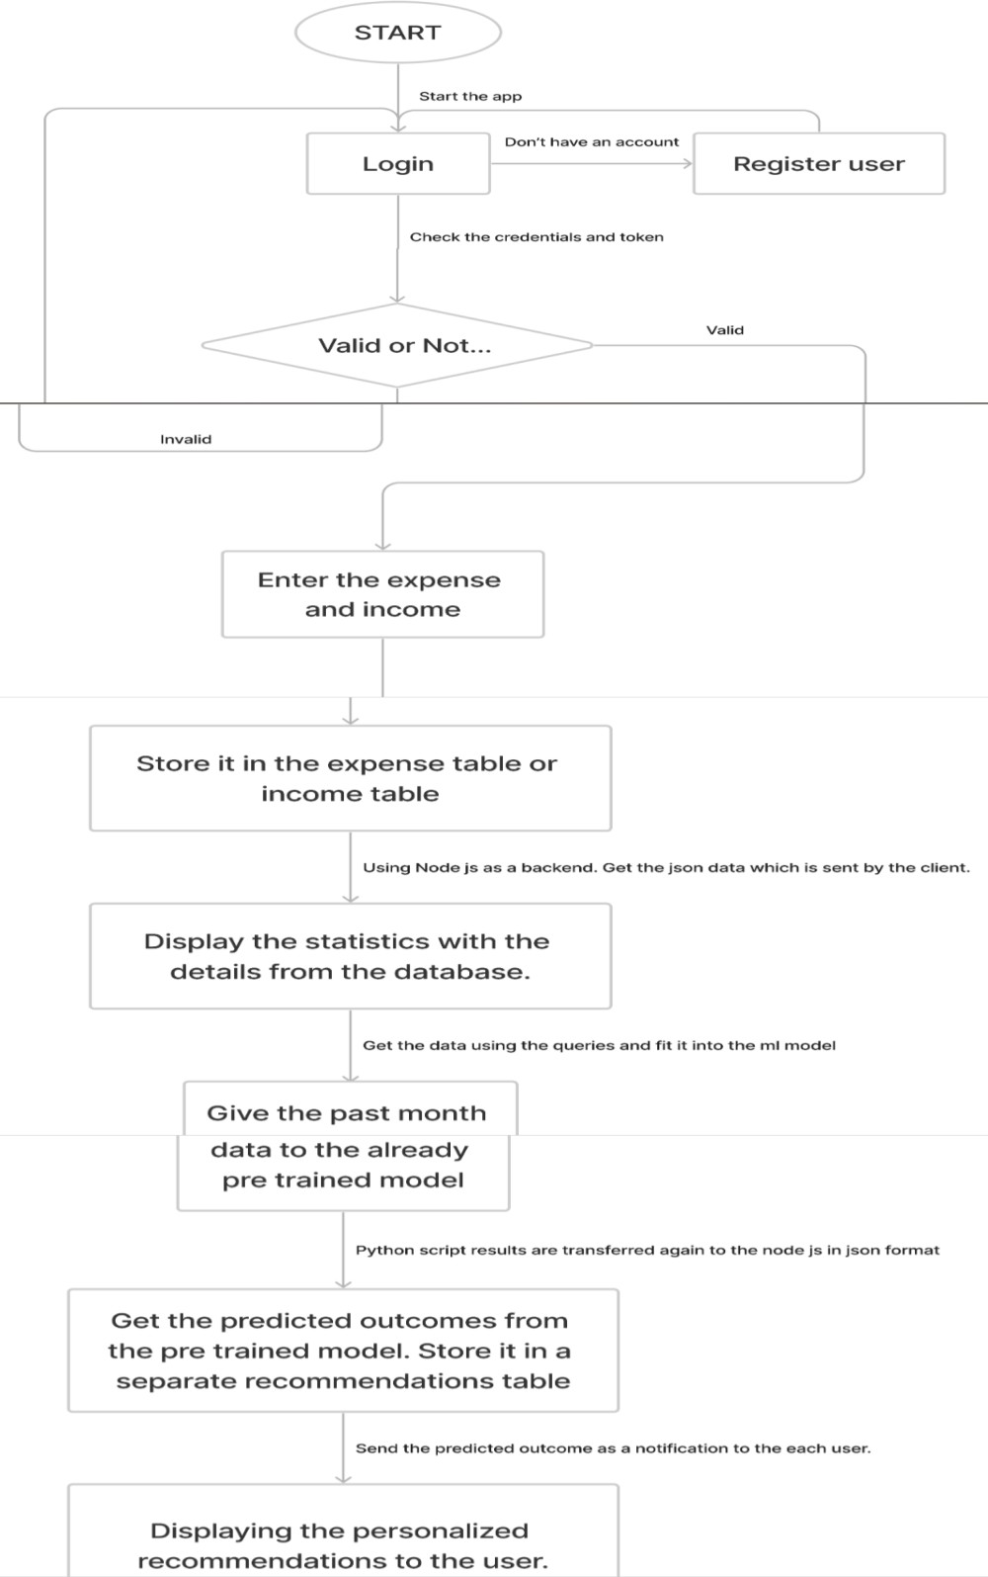

*Figure 3.6: Detailed Flowchart of the website*

# CHAPTER 4.

**RESULTS ANALYSIS AND VALIDATION**

## Implementation of solution

**1. Analysis:**

* **Tools:**
  + **Use Case Modeling:** Draw use case diagrams using tools like draw.io, Lucidchart, or Visual Paradigm.
  + **Requirement Gathering:** Utilize tools like Figma, Tailwind, other such frameworks.

**2. Design:**

* **Tools:**
  + **UML Diagrams:** Create class diagrams, sequence diagrams, and activity diagrams using tools like PlantUML, draw.io, or Visual Paradigm.
  + **Wireframing:** Design the user interfaces with tools like Figma, Adobe XD, or Sketch.
  + **Solid Models (if applicable):** For any hardware components, use CAD tools like AutoCAD, Fusion 360, or SolidWorks.

**3. Report Preparation:**

* **Tools:**
  + **Documentation:** Use collaborative writing tools like Google Docs, Microsoft Word, or LaTeX for preparing project reports.
  + **Version Control:** Implement version control using Git and host documentation on platforms like GitHub or GitLab.

**4. Project Management and Communication:**

* **Tools:**
* **Project Management:** Utilize tools like Jira, Trello, or Monday.com for task tracking and project management.
* **Communication:** Use Slack, Microsoft Teams, or Discord for team communication and collaboration.

**5. Implementation:**

* **Tools:**
  + **Backend Development:** Use frameworks like Django (Python), Spring Boot (Java), or Express (Node.js).
  + **Frontend Development:** Choose HTML, CSS, TailWind, JavaScript.
  + **Database:** Use modern databases like PostgreSQL or MongoDB.
  + **Version Control:** Implement Git for source code version control.

**6. Testing/Characterization/Interpretation/Data Validation:**

* **Tools:**
  + **Automated Testing:** Utilize testing frameworks like JUnit (Java), PyTest (Python), or Jest (JavaScript).
  + **Continuous Integration:** Set up CI/CD pipelines using tools like Jenkins, Travis CI, or GitHub Actions.
  + **Load Testing:** Use tools like Apache JMeter or Gatling for simulating high loads.
  + **Data Validation:** Implement data validation using tools or libraries suitable for your chosen programming language.

**7. Documentation:**

* **Tools:**
  + **API Documentation:** Use tools like Swagger or Redoc for documenting APIs.
  + **Wiki:** Set up a project wiki using tools like Confluence or GitHub Wiki.

**8. Project Deployment:**

* **Tools:**
  + **Cloud Platforms:** Deploy your application on cloud platforms like AWS, Azure, or Google Cloud.
  + **Containerization:** Use Docker for containerizing your application.
  + **Orchestration:** If needed, use Kubernetes for container orchestration.

**9. Monitoring and Maintenance:**

* **Tools:**
  + **Monitoring:** Implement monitoring using tools like Prometheus, Grafana, or New Relic.
  + **Error Tracking:** Use tools like Sentry or Rollbar for error tracking.
  + **Logging:** Utilize ELK Stack (Elasticsearch, Logstash, Kibana) or similar tools for centralized logging.

**10. Security:**

* **Tools:**
  + **Security Scanning:** Use tools like OWASP ZAP or SonarQube for security scanning.
  + **Authentication and Authorization:** Implement OAuth 2.0 or OpenID Connect for secure user authentication.

**11. Compliance:**

* **Tools:**
  + **Code Analysis:** Utilize tools like SonarQube to ensure code quality and compliance.
  + **Legal Compliance:** Consider using tools to scan for open-source license compliance, such as FOSSA.

**12. Feedback and Iteration:**

* **Tools:**
  + **Feedback Collection:** Use tools like SurveyMonkey, Typeform, or Google Forms for collecting feedback.
  + **Issue Tracking:** Continue using project management tools for issue tracking and iteration planning.

# CHAPTER 5.

**CONCLUSION AND FUTURE WORK**

## Conclusion

This project intends to provide a user-centric financial management solution with the objectives of enhancing financial awareness, boosting savings, and promoting responsible

financial behaviour to solve the issue of poor financial management among individuals. The project's goals, deadlines, and methodology were all clearly and concisely stated. As with any project, there might be anticipated outcomes, deviations, and explanations for those deviations.

**Expected Results/Outcomes:** The following outcomes are predicted from this project: A deeper awareness of one's financial status should help users make better financial decisions because of the full financial management solution being in place.

**Increased Savings:** We anticipate an increase in customers' savings rates as they work toward reaching their financial goals thanks to efficient budgeting and goal-setting capabilities.

**Behavioral Change:** The incorporation of behavioral economics tools, such as gamification features and behavioral nudges, is anticipated to favourably influence financial behaviour by encouraging users to make responsible financial decisions. Reduced Debt: Due to enhanced financial awareness and budgeting, users who actively use the financial management application are likely to report lower levels of debt.

**Better Financial Goal Achievement:** It is anticipated that users will meet their financial objectives more frequently when they have the option to define and monitor their goals.

**Deviations from Expected Results and Reasons:** While we expect the project to produce favourable results, there may be some variations from these expected results.

These variations could be explained by several variables, including:

**User Adoption:** If the rate of user adoption is lower than anticipated, deviations may happen. This might be brought on by a lack of marketing and outreach efforts or a failure to clearly explain the advantages of the financial management application.

**User Behaviour:** Users' financial behaviour is complicated and subject to a wide range of outside influences. Even with the addition of behavioral nudges, deviations may still occur if users do not participate as expected.

**Economic Context:** Financial behaviour may be influenced by the general economic context. Users' capacity to save and reach their objectives may be impacted by macroeconomic events like economic downturns, which can cause variations in results.

**Competitive Environment**: Variations in user uptake and engagement may result from the existence of rival financial management solutions or from changes in the competitive environment.

**Data Security Issues:** Users may not fully trust the system if there are serious data security breaches or privacy issues, which could change how engaged they are with the system.

In conclusion, the goal of this project is to develop a powerful financial management tool that has the potential to dramatically enhance users' financial security. While we hope for positive results such as higher savings, better financial literacy, and responsible financial conduct, there are several external and user-specific factors that can cause these expectations to be exceeded.

To resolve any deviations and gradually improve the efficacy of the solution, ongoing monitoring, user feedback, and adaption will be essential.

## Future work

The journey toward enabling people to improve their financial health has just begun with the successful adoption of the financial management solution. Future work will involve a variety of actions that will influence how the solution develops moving forward and how effective it becomes.

**Solution Modifications Needed:** Continuous Iteration: It is essential to regularly update and add new features. These advancements will be driven by user feedback, which will be actively

gathered and examined. The solution should continue to be innovative and in line with users' changing needs, whether it be by including new features, enhancing usability, or tweaking

already existing ones.

**Advanced Behavioral Insights**: Gamification components and behavioral nudges should be reviewed on a regular basis. The impact of the solution on financial behaviour can be increased by incorporating the most recent research findings because behavioral economics is a dynamic field.

### Change in Strategy:

**Engagement Techniques:** become a proactive financial coach rather than just a passive

instrument. Create individualized user engagement plans that include things like actionable

insights, goal monitoring, and timely reminders. Keep in touch with users to learn about their preferences and difficulties.

**Comprehensive Financial Education:** The financial literacy department should develop into an educational hub that offers a wide range of topics. Work together with professionals to provide

in-depth tutorials, articles, and other materials that address users' financial literacy requirements. Maintain it in line with the most recent financial trends and laws.

### Extension Ideas for the Solution:

**Solutions for Business:** Investigate whether the solution may be made available to businesses and organizations. Tools that support businesses in managing budgets, tracking spending, and making wise financial decisions can be quite useful.

**Financial inclusion:** By attending to the financial requirements of underserved and underbanked people, the solution's impact can be increased. Create a more user-friendly solution that is simpler to use for people who don't have access to regular banking services or much money.

**International Reach:** Consider bringing the solution to global markets. Make it fit the monetary standards, laws, and lingo used in various locales. Work together with regional financial professionals to ensure cultural and legal compliance.

**AI and Machine Learning**: To deliver predicted financial insights, embrace artificial

intelligence and machine learning. To assist users in making wiser financial decisions and avoiding traps, AI systems can evaluate users' financial data, spot trends, and provide proactive advice.

In result, the future work will focus on engagement, user education, continuous improvement, and development into new markets and domains. The financial management system can continue to have a substantial impact on people's financial well-being by remaining flexible and sensitive to users' evolving needs and utilizing cutting-edge technologies.

# REFERENCES

* "*Green Computing Research: Project management report" by Mohammad Balgoname*
* *"Masters Project CThornhill v2 final" by Cecil Thornhill*
* *"Telecom Order Management Solution Research Project" by Shailendra Shankar*
* *"CRM IN TELESHOPPING INDUSTRY" by Shriyansh Gupta*
* *"MANAGEMENT RESEARCH PROJECTERICK MAINA" by Shriyansh Gupta*
* *"Design and Implementation Money Management Web Based Application for Personal and Family" by CV. X*
* *"Financial Management System" by International Journal of Engineering & Technology*
* *"Project report on Wealth Management" by SlideShare*
* *"A study on perception of customers towards tata indica v2 project report mba" by SlidesShare*

**APPENDIX**

* + 1. Plagiarism Report
    2. Design Checklist

# USER MANUAL

(Complete step by step instructions along with pictures necessary to run the project)